**Dunamis Store Analysis**

My name is **Akinfe Taiwo Oluwabamise.** I am a data analyst tasked with performing a detailed analysis of the Dunamis Store data. I have critically analysed the data set and I have the confident that these actionable insights will help the company achieve its goal of strategic decision making.

**Introduction**

Dunamis Store sells variety of products like beer, dried plums, dried pears, dried apples, chai, coffee, chocolate biscuits mix, chocolate, clam choulder, curry sauce, green tea and so many other products to mention a few. These products are all categorized under some groups which are beverages, dried fruits and nuts, baked goods and mixed, candy, soups, sauces, condiments and jam preserver respectively. There Products were sold in four different region in the USA with over eight sales person serving as the sales representatives.

They made used of three different payment types which are Credit card, check and cash respectively.

**Data**

The data was located in the company’s database and stored as a .xlsx file. The data is primary data collected by the company itself. This makes it highly reliable.

**Data Processing**

Microsoft Excel was used for data preparation, data cleaning, exploration and visualization. I chose this tool because of its versatility and data organization functions which makes insight generation easier.

I cleaned the data by removing all nulls value and change the data type to the appropriate data types that fits and prepared it for analysis.

Analysis was done using different excel functions and the pivot table.

**Results**

**Total Revenue generated** is $435, 036.16

Total Revenue

**$435,036.16**

**Total Quantity of product sold** is 20,592

Total quantity

**20592**

**Total shipping cost** is $43,663.10

Total Shipping

**$43,663.10**

**Total count of products** in the store is 367

Total No of products **367**

**Product Performance**

**Product Performance**

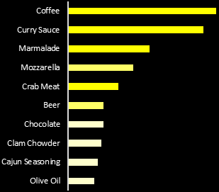

Coffee made the most sales with total revenue of $75,486 followed by Curry sauce which generated about $69,000 of total revenue. Olive oil has the least sales of $13,322.

**Product category performance**

Beverages generated the highest total revenue under the products category performance while Dried fruits and Nuts has the lowest of sales.

**Customer Performance**

**Customer Performance**

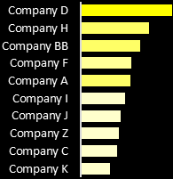

Company D made more patronages to Dunamis store by purchasing products with the total worth of $67, 181 while Company K is the least performing customer with sales worth $21,937

**Sales Rep performance**

**Sales Rep Performance**

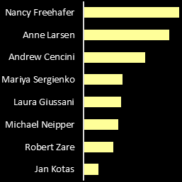

Nancy Freehafer is the most performing sales rep, she did a very good job by generating the highest total revenue of $104,242 followed by Anne Larsen while jan kotas made the lowest sales of $16,351.

**Regional performance**

**Regional Performance**

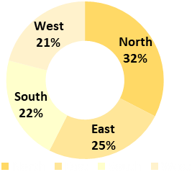

North was the most performing region that generated about 32% of the total sales in the USA for Dunamis stores while West made the least sales with 21% of the total revenue.

**Payment type count**

Credit card is the most used payment option in the store which has 211 has the total number of times it was used compared to cash which was used 43 times.

**Sales trend**

December happened to be the month with the highest sales with the total revenue of $66,643 while February has the least sales with total revenue of $19,956.

**Recommendations**

1. Dunamis store should stock more of coffee since that is the most purchased products, they can also do some campaign about olive oil and let their customers see the importance of the product and give out discount on it.
2. On product categories performance, dried fruits and nuts should be advertised to the customers and also cut down on the prices.
3. Company D has the total highest purchase and should be rewarded with quarterly or end of the year gift.
4. Nancy Freehafer is the best performing sales rep and should be rewarded with gifts or promoted to the post of Sales manager while Jan Kotas should be queried on while he is not making much sales for the store.
5. February has slow sales, customers should be given more discount every beginning of the year since there is always slow sales in order to boost sales.